NHS FRIENDS AND FAMILY TEST
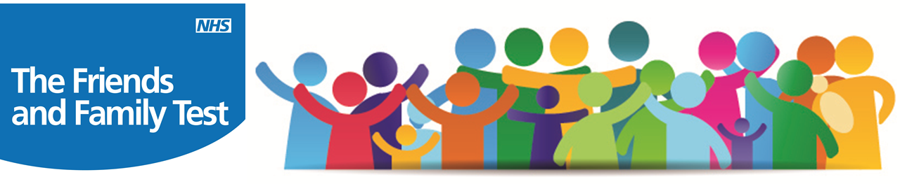

Since December 2014 reception staff have been asking patients if they would recommend our Practice to their Friends and Family....The vast majority of those asked say they would!
Many Thanks to those of you asked who have given us this feedback. We are thrilled that you would recommend us to your friends and family!
For those of you who haven’t had the opportunity to complete this feedback please speak to a member of the reception team.

